**Species compositions mediate biomass conservation: the case of lake fish communities**

**Running title:** drivers of fish biomass conservation

Ignasi Arranz1 (ignasiarranz@gmail.com), Bertrand Fournier1,2 (bfourni@gmail.com), Nigel P. Lester3,4 (nigel.lester@ontario.ca), Brian J. Shuter3,4 (brian.shuter@utoronto.ca) and Pedro R. Peres-Neto1 (pedro.peres-neto@concordia.ca)

1. Department of Biology, Concordia University, Montreal, Quebec, Canada.
2. Institute of Environmental Science and Geography, University of Potsdam, Potsdam, Germany.
3. Department of Ecology and Evolution, University of Toronto, Toronto, Ontario, Canada.
4. Science and Research Branch, Ontario Ministry of Natural Resources and Forestry, Ontario, Canada.

5Corresponding author. E-mail: [ignasiarranz@gmail.com](mailto:ignasiarranz@gmail.com)

**Open Research statement**

Data is available at github.com/ignasiarranz/Arranz.et.al.Ecology.git

# Abstract

Environmental and geographical factors are known to influence the number, distribution and combination of species that coexist within ecological communities. This, in turn, should influence ecosystem functions such as biomass conservation, or the ability of a community to sustain biomass from small to large organisms. We tested this hypothesis by assessing the role of environmental factors in determining how biomass is conserved in over 600 limnetic fish communities spread across a broad geographic gradient in Canada. Comprehensive and accurate information on water conditions and community characteristics such as taxonomy, abundance, biomass and size distributions were used in our assessment. Results showed that species combinations emerge as one of the main predictors of biomass conservation among the effects of individual species and abiotic factors. Our study highlights the strong role that geographic patterns in the distribution of species can play in shaping key ecosystem functions, with consequences for ecosystem services such as the provision of harvestable fish biomass.

**Key words:** Biomass distribution, community composition, diversity patterns, environmental filtering, species effect, trophic food web

# Introduction

A central goal in ecology is to understand the processes determining the particular combination of species found in local communities (MacArthur 1972; Gaston and Blackburn 2000). Another central goal is to uncover the processes that shape food web structure and consequently determine ecosystem functioning (Loreau et al.2001; Thompson et al. 2012). Individual species differ in their physiological adaptations to environmental factors and their capacities to acquire resources and meet their nutritional demands. Given that spatial patterns of species distributions do not vary randomly over space (MacArthur 1972; Gaston and Blackburn 2000), one should expect strong links between community composition and ecosystem functioning.

Classic trophic models assume that biomass within trophic levels depends on the interplay between resources available, maintenance costs and energy losses (Lindeman 1942; Yodzis 1984). Recent food web models, however, seem to neglect the influence of species-specific differences on ecosystem processes (Bolchoun et al. 2017). Species can vary dramatically in the ways they obtain energy via trophic interactions (Trussell et al. 2006; Harvey et al. 2009) and compete for resources (Smith et al. 2017). The ability of a community to sustain biomass from small to large organisms (hereafter referred to as ‘biomass conservation’) should then depend, in part, on the ecological associations among species. For instance, in host-parasitoid food webs, biomass conservation depends on how well the nutritional content of the host and the nutritional requirements of the parasitoid match (Harvey et al. 2009). Herbivore biomass conservation has been shown to be influenced by the nutritional quality of primary producers (Cebrian et al. 2009) and predation risk (McPeek et al. 2001). The ability of predators to gain and store biomass can be limited by the size range of available prey (Giacomini and Shuter 2013), the ontogenetic stage of prey (Barneche and Allen 2018), and feeding adaptations for prey capture and handling (Brose et al. 2008). Taken together, species-specific variation in the nutritional value of primary or secondary producers and in the ability of consumers to acquire and conserve energy in the form of biomass should vary among local communities sharing a common regional species pool.

A parallel can be drawn with Diamond’s assembly rules (Diamond 1975) in which certain species combinations become “forbidden” as they become prohibitively inefficient in transferring energy in the form of biomass across trophic levels, thus lowering the overall level of biomass conservation within a community. As such, there may be several different species combinations that are similar in the degree to which they support high (or low) levels of community biomass conservation. Specifically, combinations of species that are tightly associated through niche complementarity (e.g., selective consumers on exclusive producers) can minimize their energetic costs (Ryder and Kerr 1990) and, all else being equal, should support greater biomass conservation. Biomass conservation may also vary as a function of important environmental and ecological features such as climatic gradients or assembly processes. For instance, temperature determines the fitness and distribution of ectothermic species such as fish or amphibians (Shuter et al. 2012), which in turn can affect local species compositions. Moreover, temperatures also play an important role in metabolism, which should influence standing biomass and richness (Brown et al. 2007). Species-rich communities tend to accumulate more biomass because of overall increases in the number of energy pathways, greater niche complementarity and/or increases in available resource niches (Tilman et al. 1997; Loreau et al. 2001). Increased habitat connectivity, for instance, could either augment the opportunities for species sorting leading to greater biomass conservation; or lead to random arrangements of species with low biomass conservation. Taken together, geographic variation in environmental conditions, species richness and species combinations across local communities should modulate biomass conservation. These links, to our knowledge, have yet to be established.

One possible reason for this knowledge gap is that many components of ecosystem functioning are challenging to quantify across large spatial scales (Thompson et al. 2012). However, for aquatic food webs, community biomass conservation (defined here as the slope of the normalized biomass spectrum, NBS: the relationship between estimated total biomass and log-scale body size bins; Sprules and Barth 2016) can be derived directly from theory linking food web structure and their energy fluxes with the distribution of biomass from small to large organisms (Kerr and Dickie 2001; Brown et al. 2007; Reuman et al. 2008). The NBS slope is also constrained by the trophic transfer efficiency and predator-prey mass rate (PPMR), several key properties for ecosystem structure and functioning (Trebilco et al. 2016; Mehner et al. 2018). Flatter NBS slopes (i.e., closer to 0) would indicate greater biomass conservation in which a given biomass at low trophic levels sustains a relatively large biomass at higher trophic levels (Kerr and Dickie 2001). Conversely, steeper NBS slopes (i.e., more negative) would indicate lower biomass conservation (Kerr and Dickie 2001). Hence, biomass conservation can serve as an inferred measure to understand trends in ecosystem functioning over space similarly to other components such as net primary productivity or herbivory rates (Cyr et al. 1997; Mehner et al. 2018; Potapov et al. 2019).

Our study focused on the variation in biomass conservation across 639 lake fish communities that are spread over a broad climatic gradient in eastern North America.These fish communities have strong biogeographical and environmental affinities and are spread over steep climate gradients (Henriques-Silva et al. 2013). Interspecific variation among fish species spans over five orders of magnitude in body mass (individuals varying from 0.1 to 19,107 g) and covers several trophic levels, thus allowing the quantification of the degree of biomass transfer from planktivores to piscivores within each lake community. Here we contrasted the relative (direct and indirect) importance of environmental factors, species richness and species compositions as drivers of the spatial variation in biomass conservation across lakes. We predicted that local environmental conditions and spatial species turnover can either (*i*) indirectly affect community biomass conservation efficiency by determining the type of species compositions across lakes which then, in turn, shape conservation efficiency or (*ii*) directly influence community biomass conservation by shaping the fundamental lake properties that drive it.

# Material and Methods

***Database***

Fish data came from 639 lakes sampled by the Ontario Broad-Scale Monitoring program (BSM; Sandstrom et al. 2011) of the Ontario Ministry of Natural Resources and Forestry (OMNRF 2012). Lakes span a latitudinal and longitudinal gradient from 43.06 °N − 54.52 °N and 95.06 °W − 76.01 °W, respectively (Fig. 1). Lakes were selected through a stratified random design, with strata defined by geographic zone and lake surface area. Lakes were sampled once between 2008 and 2012 in summer months (June to September; annual mean air temperature = -1.9 to 8.1 °C). Fish size structure data were obtained from a depth-stratified survey using overnight sets of benthic (small and large) multi-mesh gill nets (Appendix S1: Table S1). The smaller nets were not used in lakes greater than 20 m in depth but this should not influence catchability of small fish, which in turn could bias size structure, since these inhabit littoral zones were exploited by fish for refuge and food resources. All fish caught were identified at the species level and measured for fork length. Fish lengths were converted to fish weights using length-mass equations specific to each taxon (Appendix S2: Table S1 and Fig. S1). Fish biomass density (expressed as biomass of fish per unit effort, BPUE) was calculated for each length class (10 mm length classes) and species by multiplying the fish abundance density (expressed as catch of fish per unit effort, CPUE; 100m·night-1) by predicted weight (Appendix S3: Fig. S1). Because sampling efficiency of gillnets is strongly dependent on fish behavior and movement (e.g., large-bodied fish usually moves more than small-bodied fish), we controlled for the capture and encounter selectivity of the combined gears. We have included an encounter and selectivity parameters that estimated corrected BPUE values per lake, thus reducing the possible effects of gillnet selectivity (Appendix S3: Fig. S1).

***Characterizing lake environmental factors and angling pressure***

Data on local climate, lake size and lake water chemistry were obtained for each lake (Table 1). For climate, mean annual air temperature (MAT, °C) and growing degree days > 5 °C (GDD) were derived from local 30-year climate air temperature for the period 1981-2010 (Cross et al. 2012). Three metrics of lake size (surface area: AREA, km2; maximum depth: DEPMAX, m; mean depth: DEPMN, m) were compiled by OMNRF (OMNRF 2012). For water chemistry, spring sampling of each lake provided measures of conductivity (COND, µS.cm-1), dissolved organic carbon (DOC, mg·l-1), and total phosphorus (TP, µg·l-1). In addition, summer sampling provided Secchi depth (SEC, m). We focused on these environmental factors initially since they were shown to be drivers of North American limnetic fish communities (Chu et al. 2016; Jackson et al. 2001). Given that Ontario lakes are often used for recreational angling, which in turn can affect fish density and body size distributions (Chu et al. 2016), we also included a measure of angling pressure in our analysis. Aerial surveys of angling activity were used to estimate lake-specific values for annual angling pressure (angler-hours·ha−1·year-1) following Chu et al. (2016).

***Quantifying changes in species composition among lakes***

We used the eigenvector values of two separate Principal Coordinate Analysis (PCoA) extracted from *lake by species* communitymatrices (one based on species presence-absence and another on biomass data) to summarize variation in species composition among lakes. Each community matrix was Hellinger-transformed (Legendre and Legendre 2012) prior to PCoA to reduce the effects of highly abundant species in any given lake. The 83 PCoA axes (i.e., 1 less than the number of species due to the standardization involved in PCoA) represented all the variation in species compositions across lakes (see selection of the PCoA axes in *Statistical analyses* and Appendix S4: Fig. S1). Lakes with similar values across PCoA axes represented similar species compositions.

***Estimating biomass conservation***

Biomass conservation of each lake (fish community) was calculated as the slope of the Normalized Biomass Spectrum (NBS slope; Sprules and Barth 2016). First, we classified body mass into a geometric series of size intervals where the lower bound of each interval differed by a factor of two (e.g., 2 g, 4 g, 8 g, and so on: Appendix S5: Table S1, Figs. S1 and S2). For each body mass class, we calculated biomass per unit effort (BPUE) as an index of biomass density. Then, normalized scores (normalized corrected BPUE) were calculated as the biomass index divided by interval (Appendix S5: Table S1; Sprules and Barth 2016). The NBS slope was calculated using ordinary-least squares (OLS) to regress log2 (normalized corrected BPUE) on log2 (body mass class). Overall, the adjusted R2 was uniformly high across lakes (mean = 0.83, SD = 0.12), validating that the OLS method provided a strong fit to the biomass distributions (Appendix S5: Fig. S3). Our findings were also robust to various methodological approaches, including varying bin size prior to OLS estimation and applying maximum likelihood methods to bounded bin data as suggested by Edwards et al. (2017) (Appendix S5; Figs. S4 and S5). Even the slopes based on simple OLS regressions varied around the theoretical expected value of -1 (NBS slope = -1; Sprules and Barth 2016). For more detailed explanations on the NBS slope estimation, see Appendix S5.

***Statistical analyses***

We used multiple regressions to determine the broad-scale influence of environmental factors (climate, lake size, water chemistry) on biomass conservation. Some variables were log-transformed (i.e., AREA, DEPMAX, DEPMN, COND, SEC, TP, AP) to meet the assumptions of residual normality and homoscedasticity. Extremely highly correlated variables (≥0.55) were excluded (i.e., GDD, DEPMAX, SEC and TP; Appendix S6: Table S1). We extended these analyses to assess how various measures of fish community structure (i.e., species richness and species composition) accounted for variation in biomass conservation. Even though overfitting is not an issue here because the number of lakes is much greater than the number of PCoA axes describing species compositions across lakes, we used a least absolute selection and shrinkage operator (LASSO) to select axes that contributed to biomass conservation in a multiple regression model with biomass conservation as the response variable. LASSO estimates a penalty parameter (i.e., λ) via a 10K-fold cross validation (100 times) that drops variables with little weight to the response variable (the larger the value of λ, the more coefficients will be set to zero). In total, 55 axes for the biomass data and 20 axes for the presence-absence data were retained out of 83 axes. Note that adjusted R2 are robust against overfitting (Peres-Neto et al. 2006) even though the total number of predictors was much smaller than the number of lakes when combining the selected PCoA axes to represent species compositional differences and environmental predictors (e.g., 60 predictors, 55 axes for the biomass data + five environmental variables, in total over 639 lakes). We examined the multicollinearity through variance inflation factors (vif) in our multiple regression models but all predictors showed low degree of multicollinearity (< 3, Dormann et al. 2013). We then computed the Moran’s I correlograms to evaluate the degree of spatial autocorrelation of the residuals from the regression models but the values in all models were very close to 0, indicating that model predictors accounted for the spatial patterns in biomass conservation (Appendix S7: Fig. S1).

We used variation partitioning (Borcard et al. 1992; Peres-Neto et al. 2006) to estimate the independent and shared contributions of environment and fish community structure (richness and species compositions) accounting for the variation in biomass conservation across lakes. Angling pressure was added as a predictor together with the environment predictor matrix. Even though different species compositional axes characterize different communities in terms of their species compositions, one critical aspect is to demonstrate that a wide variety of species compositions can lead to low and high values of biomass conservation. Imagine an extreme fictional case in which lakes are dominated by only two distinct types of communities in terms of species composition. In this case, only one PCoA axis would be important in describing NBS slope variation as a function of species compositions. However, in this fictional case one should be cautious concluding that composition drives biomass compositions because the lack of species variation across communities; it would be like fitting a regression with “two” community data points. Stronger evidence would be generated if different sets of species compositions would lead to low and high degrees of biomass conservation. To tackle this issue, we conducted variation partitioning using a generalized least squares (GLS) approach in which beta-diversity was used as weights in the fitting process of the model (Appendix S8: Table S1 and Fig. S1). The goal of this model is to reduce the contribution of lakes similar in their species compositions in explaining variation in biomass conservation.

Because multiple fish species are widely distributed and could potentially correlate strongly with compositional differences among lakes, we implemented a species-level jackknife procedure to contrast the predictive ability of each single species against PCoA axes calculated without that species. For each species, we extracted PCoA axes from a community matrix in which the distribution (column) of the target species was removed. We then conducted variation partitioning to contrast the relative contributions of the PCoA axes retained by the LASSO (but without the jackknifed species) against the distribution of the target (jackknifed) species. We repeated the procedure for each species and calculated the adjusted R2 (i.e., correcting for number of predictors and number of lakes) of each component on the basis of variation partitioning. If the effects of species compositions were confounded with the individual influence of particular species, then their shared variation in explaining biomass conservation would be high.

We used a canonical redundancy analysis (RDA) to assess the effects of environmental conditions on species compositions. To do this, climate, lake size, and water chemistry were treated as predictors and PCoA axes describing species compositional differences among lakes as response variables. This served as a means to estimate how the indirect effects of environment on biomass conservation may affect our interpretation of the direct effects of species composition. Finally, we calculated the contributions of individual lakes to the overall beta diversity across all lakes (LCBD; Legendre and Cáceres 2013). This is a metric that allows us to estimate how unique or common fish communities are in their species compositions relative to one another. Regressing biomass conservation on LCBD values allowed us to make a link between the frequency of species co-occurrences and the degree of trophic association. All analyses were conducted in the statistical environment R 3.5.2 (R Development Core Team 2018).

# Results

***Associations between abiotic factors and NBS slopes***

Six environmental variables jointly accounted for 27% (adjusted R2) of the spatial variation in NBS slopes (Fig. 2 and Appendix S9: Tables S1 and S2). These predictors included lake size variables (AREA and DEPMN), one climate variable (MAT) and two measures of water chemistry (DOC and COND). Biomass conservation was positively associated to lake size and DOC, and negatively to MAT and COND (Appendix S9: Table S1). The independent contributions of temperature and lake size were roughly equal while the independent contribution of water chemistry was much lower (0.06, 0.06 and 0.03, respectively; Appendix S9: Table S3).

***Associations between fish communities and NBS slopes***

NBS slopes were not related to species richness, but rather strongly influenced by the species compositions within lakes: (*i*) richness alone was unrelated to NBS slopes (Appendix S10: Table S1); (*ii*) when richness was added to the environmental model, it had a weak negative effect and accounted for a trivial increment to the overall adjusted R2 (Appendix S10: Table S2); (*iii*) the relevance of richness as a predictor of NBS slopes disappeared entirely when species compositional differences were added to the environmental model (Appendix S10: from Table S3 to Table S5).

Adding predictors based on species compositions to the environmental model substantially increased its power (expressed as adjusted R2) to predict NBS slopes (Fig. 2d and Appendix S11: from Table S1 to Table S3): an increase of 20% when predictors of species compositions were produced on the basis of the presence-absence data, 50% based on the species biomass data, and 51% when both sets of predictors of species compositions were considered together (Fig. 2 and Appendix S11: Tables S4 and S5).

Variation partitioning revealed that most of the variation in NBS slopes could be directly explained by species compositions and not by environmental factors (Fig. 2). The independent contribution of environmental factors was not important (<0.1%) while the independent contribution of species compositions explained an additional 20% and 50% (adjusted R2) of the total variation in NBS slopes (Fig. 2c–d) based on compositional variation of presence-absence and biomass species, respectively. The generalized least squares (GLS) approach for variation partitioning strengthens these results even further (Appendix S8).

Likewise, the shared contribution of environment and community structure was equal to the adjusted R2 for the environment alone 27% (Figs. 2a–d). The redundancy analysis (RDA) indicated that environmental variation explained 32% and 25% of the variation in species compositions among lakes based on biomass and presence-absence composition data, respectively. As such, the shared variation between environmental and compositional variation in explaining NBS slopes may be due to either direct effects of environmental features on both biomass and species compositions; or indirect effects on species contributions that have further effects on biomass conservation. Regardless of these two possibilities, species compositional differences are very strong independent predictors of NBS slopes.

Similar results were obtained when considering only the deep lakes where strata > 20 m were sampled with large mesh gear alone (Appendix S11: Table S5) indicating that our results were robust against any potential sampling biases due to not catching small fish in relatively deep lakes. We did not detect an independent influence of angling pressure on NBS slopes (Appendix S12: from Table S1 to Table S4).

***Species compositions versus single species as predictors of NBS slopes***

Species compositions among lakes always explained much greater variation in NBS slopes than any single species alone (Fig. 3 and see Appendix S13: Fig. S1). Note that for simplicity, environmental variation was not considered in these models. The contribution of species compositions to NBS slopes changed as a function of which species was jackknifed from the community matrix to have its contribution estimated. This was an obvious consequence of recalculating PCoA axes without the target species. Species compositions alone explained on average 79% (biomass data) and 42% (presence-absence data) of the total variation in NBS slopes (Fig. 3a–b). In contrast, the average contribution of individual species to NBS slopes was about 1% for both presence-absence and biomass-based compositional predictors (Fig. 3a–b). The shared variation between individual species contribution and compositional differences on NBS slopes was < 1% on average (Fig. 3a–b). Taken together, the differences in species compositions and not the occurrence of any particular species was the most important factor driving variation in fish NBS slopes among lakes.

***Rare versus common species compositions***

The degree of uniqueness in species compositions among lakes (i.e., Local Contribution to Beta Diversity, LCBD) was strongly geographically structured (Fig. 4a–b), declining from south to north (Fig. 4c). It was negatively correlated with NBS slopes (Fig. 4b). In northern lakes, nearby communities had similar species compositions (low LCBD values) and conservation values were typically high (Fig. 4b–c). In the south, species compositions differed more from lake to lake (LCBD values typically high) and conservation values were typically low (Fig. 4b-c).

# Discussion

We have investigated how NBS slope, a proxy for community biomass conservation (i.e., the ability of communities to retain biomass from small to large individuals) varies as a function of environmental gradients reflecting the non-random nature of spatial variation in species compositions. Our results show that species composition was the most important driver influencing biomass conservation. However, environmental conditions such as temperature may also affect directly the selection of species compositions on the basis of their energetic efficiencies. For instance, fish inhabiting cool waters expend less energy than fish in warm waters, which is consistent with the strong north-to-south spatial variation in biomass conservation (Fig. 1).

***Environmental factors as drivers of biomass conservation***

Environmental factors limit the number of realized species compositions and their associated spatial patterns of biomass conservation, as shown by the RDA analysis of species compositions on environmental variation. One example of how the environment limits the membership in species compositions is the role of climate in excluding groups of species from viable combinations based on species-specific thermal preferences (Figs. 5 and 6). As temperature increases, realized species compositions shift from species adapted to cold/cool water towards species adapted to warmer water; this shift is accompanied by a downward shift in biomass conservation (Figs. 5 and 6). Examples of warm-adapted species are *Lepomis gibbosus*, *Micropterus salmoides* and *Perca fluviatilis* whereas cold-adapted species are *Coregonus clupeaformis*, *Lota lota* and *Salvelinus namaycush* (Fig. 5).

Note that some single species are associated with well-defined ranges of biomass conservation, but they did not appear as good predictors of biomass conservation (Fig. 3). For example, brook trout (*Salvelinus fontinalis*) is a cold-water salmonid that inhabits small lakes where biomass conservation is low, fish communities are simple (i.e., low richness) and competitors are absent (Fig. 6). With increases in lake size, limits on species compositions are relaxed, habitat diversity increases, larger competitors are present, and brook trout become rare. Brook trout are rarely found in lakes > 300 ha and, since they are typically the largest species in the simple competitor-free communities that support them, their relatively small adult body size could account for the low values of biomass conservation observed in those communities. However, since there are many brook trout-free systems with low biomass conservation values, brook trout presence alone is not a reliable predictor of biomass conservation (Fig. 3).

In other cases, the maximum adult size for some top predators varies widely across communities and is controlled by the specific composition of prey species present in the community. Since top predators are typically the largest species found in the lakes that support them, changes in their maximum adult size can strongly affect biomass conservation. For example, lake trout (*Salvelinus namaycush*) was present in lakes with biomass conservation values varying from -1.25 (comparable to those lakes with brook trout) to -0.9 (Fig. 6d). Differences in biomass conservation across these lakes were associated with differences in the lake trout prey fish community that were only loosely linked to differences in lake size (see labeled points in Fig. 6d) but were consistent with, and predicable from, the many published empirical and modeling studies that demonstrate how lake trout adult size varies with the prey species available: (*i*) growth efficiency in lake trout increases with prey size (Kerr 1971; Cruz-Font et al. 2019), (*ii*) maximum adult size in lake trout increases with available prey size (Kerr 1971; Shuter et al. 2016) and (*iii*) available prey size for lake trout increases substantially when large cold water pelagic forage fish are available (Kerr 1971; Shuter et al. 2016). In small lakes, cold water pelagic habitat is typically too limited to support the larger cold-water prey species (e.g., Coregonids) needed to support larger lake trout body sizes (Kerr 1971; Shuter et al. 2016). In these lakes, lake trout maximum sizes are similar to brook trout maximum sizes (400 to 500 mm; Shuter et al. 1998; Cruz-Font et al. 2019) and biomass conservation values (see points C0P0 and C0 in Fig. 6d) are similar to those in brook trout lakes. As lake size increases, prey Coregonid species are more likely to be present (see points C1, and C2 in Fig. 6d), allowing lake trout to achieve a larger body size (up to 900 mm) and leading to higher biomass conservation. In larger lakes, higher biomass conservation values are only realized if specific forage species are present to augment lake trout growth efficiency and permit biomass to accumulate at larger adult sizes. It is the specific compositions of prey species that drive the changes in biomass conservation, and the occurrence of these compositions only varies loosely with lake size. While our environmental model tracked the variation in biomass conservation as air temperature and lake area change across Ontario, the species composition models accounted for much more of the variation in biomass conservation than environmental features.

***Species richness, species compositions and biomass conservation***

The effects of species richness and species compositions on ecosystem processes have been the focus of much research (Hooper et al. 2005; Allgeier et al. 2015). We expected higher biomass conservation in richer communities because of overall increases in the number of energy pathways, greater niche complementarity and/or increases in available resource niches (Tilman et al. 1997). This expectation was not upheld by our results: richness had little influence on biomass conservation. Conversely, particular species compositions, essentially independent of richness, were extremely influential. In many aquatic systems, organisms typically use body size to discriminate among prey and, consequently, are considered as trophic generalists (Chase 2000). The breadth of prey types for a single fish species can span many trophic levels because of indeterminate growth over a size range that can cover several orders of magnitude from egg to adult. Thus, we might expect community biomass conservation to be relatively insensitive to the arrival or extinction of a single species. This assertion is supported by the fact that no single species was a good predictor of biomass conservation (Fig. 3).

For example, northern and southern lakes within our study have a similar number of species yet differ in their biomass conservation values. This finding reinforces our hypothesis that specific composition of species characteristics mediate biomass conservation. These differences may be due to physiological adaptations. In northern lakes, longer winters force fish to store more energy in the summer through biomass over-accumulation in order to endure the prolonged period of winter energy scarcity. Therefore, northern lakes should comprise species that can accumulate biomass efficiently over short time periods (Shuter et al. 2012).

***Rare versus common species compositions and their effects on biomass conservation***

We found that communities consisting of common species compositions had greater levels of biomass conservation in contrast to rare communities (Fig. 4). Northern Ontario lakes presented greater spatial similarities in their environments (Appendix S14: Fig. S1) and more common species compositions (Fig. 4) than southern lakes. Predictable community composition should have either small (rare species compositions) or large (frequent species compositions) LCBD values. Common species compositions (large LCBD values) could have been the result of species with greater trophic compatibility (“harmonic communities” sensu Ryder and Kerr 1990) that allowed these species to increase their fitness and expand their ranges more or less together as a result. Moreover, northern lakes provide harsh winter conditions that only some species can tolerate. This common selection pressure could have severely limited the number of viable community types in the region. Alternatively, it is possible that rare and random communities that occur mostly in southern lakes are the result of high environmental turnover and greater spatial connectivity in this region (see Henriques-Silva et al. 2013 for a study of connectivity in Ontario lake-fish communities). The conditions may create species compositions that are more often found away from their optimal environmental conditions (i.e., marginal niches). These rarer and random compositions would then exhibit lower trophic compatibility and reduced energetic efficiency, leading to lower biomass conservation. Combined, our results suggest that although environmental conditions select local species compositions, the differences in the spatial turnover of environmental conditions may promote (or limit) the development of stable community compositions, with impacts on realized levels of t biomass conservation.

***Angling pressure and biomass conservation***

Contrary to observations common in commercial fisheries (Jennings and Blanchard 2004; Chu et al. 2016) and changes on biomasses of target species in Ontario (e.g., lake trout; Shuter et al. 1998), our analyses did not reveal a negative impact of fishing on community biomass conservation. This is not surprising because angling pressure was quite low (median = 3.6 hours·ha-1·year-1, exceeding 10 hours·ha-1·year-1 in southern parts of Ontario) compared to other studies focusing on more heavily exploited areas (e.g., Shuter et al. 1998; Wilson et al. 2019). Our inability to detect an angling effect may be also due in part to our choice of measurement. Angling effort on Ontario lakes can vary widely from year to year but biomass conservation has much greater temporal inertia. The question is whether historical angling pressure has impacted biomass conservation, yet our measurement of angling pressure is a single-year estimate taken the same year that we measure biomass conservation. This measurement may not provide a good index of historical pressure because, in these fisheries, anglers are highly mobile, and the spatial distribution of fishing pressure is expected to vary through time, in response to changes in fish communities driven by fishing (Hunt et al. 2011). Moreover, the dense distribution of lakes across Ontario may weaken the capture efficiency as anglers choose lakes that have not been impacted by fishing activities (Wilson et al. 2019).

Conclusions

Our study generates new insights into the processes driving ecosystem functioning by providing strong support for our prediction that biomass conservation would be strongly affected by non-random spatial variation in the species compositions of communities. This prediction was grounded in the hypothesis that species-specific differences in trophic transfer efficiency could shape overall ecosystem processes in ways that would affect biomass conservation. Our results also have important implications for conservation and management perspectives. Climate change will shift southern climates towards the north, which could change the stability of community composition as species disperse northward, thereby implying a reduction in biomass conservation at the regional level. We suggest that stocking programs could focus on building combination of species that are most energetically efficient to allow increased community biomass conservation. Thus, a balance between non-stocked and stocked fish biomass species would satisfy both the anglers by catching bigger stocked fish and managers by improving ecosystem health. Finally, our study should encourage new lines of research into the processes underlying how biodiversity changes across communities and how these changes affect ecosystem functioning.

Acknowledgments

IA and BF acknowledge funds from the Canadian Network for Aquatic Ecosystem Services and the Canada Research Chair program (Canada Research Chair in Spatial Ecology and Biodiversity; chair holder is PRPN). We would like to thank Cindy Chu and Henrique Giacomini from the Ontario Ministry of Natural Resources and Forestry (OMNRF) for their technical support and discussions that much improved the quality of the work.

Literature Cited

Allgeier, J. E. et al. 2015. Metabolic theory and taxonomic identity predict nutrient recycling in a diverse food web. Proceedings of the National Academy of Sciences **112**: E2640–E2647.

Barneche, D. R. and A. P. Allen. 2018. The energetics of fish growth and how it constrains food-web trophic structure. Ecology Letters **21**: 836–844.

Bolchoun, L., B. Drossel, and K.T. Allhoff. 2017. Spatial topologies affect local food web structure and diversity in evolutionary metacommunities. Scientific Reports **7**: 1818.

Borcard, D., P. Legendre, and P. Drapeau. 1992. Partialling out the spatial component of ecological variation. Ecology **73**: 1045–1055.

Brose, U., R. B. Ehnes, B. C. Rall, O. Vucic-Pestic, E. L. Berlow, and S. Scheu. 2008. Foraging theory predicts predator-prey energy fluxes. Journal of Animal Ecology **77**: 1072–1078.

Brown, J. H., A. P. Allen, and J. F. Gillooly. 2007. The metabolic theory of ecology and the role of body size in marine and freshwater ecosystems. In: Body Size: The structure and function of aquatic ecosystems (eds. A. G. Hildrew, D. G. Raffaelli and R. Edmons-Brown. Cambridge University Press, Cambridge, pp. 1–15.

Chu, C. et al. 2016. Catch-per-unit-effort and size spectra of lake fish assemblages reflect underlying patterns in ecological conditions and anthropogenic activities across regional and local scales. Canadian Journal of Fisheries and Aquatic Sciences **73**: 535–546.

Cebrian, J. et al. 2009. Producer nutritional quality controls ecosystem trophic structure. PLoS ONE **4**: 1–5.

Chase, J. M. 2000. Are there real differences among aquatic and terrestrial food webs? Trends in Ecology and Evolution **15**: 408–412.

Cross, J. et al. 2012. Historic Climate Analysis Tool [digital application]. Version 2.5. Ontario Ministry of Natural Resources, Northwest Science and Information, Thunder Bay, Ontario.

Cruz-Font, L. et al. 2019. Life at the top: Lake ecotype influences the foraging pattern, metabolic costs and life history of an apex fish predator. Journal of Animal Ecology **88**: 702–716.

Cyr, H., R. Peters, and J. A Downing. 1997. Population density and community size structure: comparison of aquatic and terrestrial systems. Oikos **80**: 139–149.

Diamond, J. M. 1975. Assembly of species communities. In: Ecology and evolution of communities (eds. M.L. Cody and J.M. Diamond). Harvard University Press, Massachusetts, pp 342–344.

Dormann, C. F. et al. 2013. Collinearity: a review of methods to deal with it and a simulation study evaluating their performance. Ecography **36**: 27-46.

Gaston, K., and T. M. Blackburn. 2000. Pattern and Process in Macroecology. Wiley-Blackwell, Oxford, pp. 1–377.

Giacomini, H. C., and B. J. Shuter. 2013. Adaptive responses of energy storage and fish life histories to climatic gradients. Journal of Theoretical Biology **339**: 100–111.

Harvey, J. A., R. Wagenaar, and T. M. Bezemer. 2009. Interactions to the fifth trophic level: Secondary and tertiary parasitoid wasps show extraordinary efficiency in utilizing host resources. Journal of Animal Ecology **78**: 686–692.

Henriques-Silva, R., Z. Lindo, and P. R. Peres-Neto. 2013. A community of metacommunities: exploring patterns in species distributions across large geographical areas. Ecology **94**: 627–639.

Hooper, D. U. et al. 2005. Effects of biodiversity on ecosystem functioning: a consensus of current knowledge. Ecology Monographs **75**: 3–35.

Hunt L. M., R. Arlinghaus, N. P. Lester, and R. Kushneriuk. 2011. The effects of regional angling effort, angler behavior, and harvesting efficiency on landscape patterns of overfishing. Ecology Applications **21**: 2555–2575.

Jackson, D. A., P. R. Peres-Neto, and J. O. Olden. 2001. What controls who is where in freshwater fish communities – the roles of biotic, abiotic, and spatial factors. Canadian Journal of Fisheries and Aquatic Sciences **58**: 157–170.

Jennings, S., and J. L. Blanchard. 2004. Fish abundance with no fishing: predictions based on macroecological theory. Journal of Animal Ecology **73**: 632–642.

Kerr, S. R. 1971. A simulation model of lake trout growth. J. Fish. Res. Bd. Canada, **28**: 815-819.

Kerr, S. R., and L. M. Dickie. 2001. The biomass spectrum: a predator-prey theory of aquatic production. New York, NY: Columbia University Press.

Legendre, P. and L. Legendre. 2012. Numerical Ecology. Amsterdam, Netherlands: Elsevier.

Legendre, P., and M. D. Cáceres. 2013. Beta diversity as the variance of community data: dissimilarity coefficients and partitioning. Ecology Letters **16**: 951–963.

Lindeman, R. L. 1942. The trophic-dynamic aspect of ecology. Ecology **23**: 399–417.

Loreau, M. et al. 2001. Biodiversity and Ecosystem Functioning: Current Knowledge and Future Challenges. Science **294**: 804–808.

MacArthur, R. H. 1972. Geographical ecology: Patterns in the distribution of species. Princeton University Press, Princeton, 1–288.

McPeek, M. A., Grace, M., and Richardson, J. M. L. 2001. Physiological and behavioral responses to predators shape the growth/predation risk trade-off in damselflies. Ecology **82**: 1535–1545.

Mehner, T. et al. 2018. Empirical correspondence between trophic transfer efficiency in freshwater food webs and the slope of their size spectra. Ecology **99**: 1463–1472.

Ontario Ministry of Natural Resources and Forestry (OMNRF). 2012. Ontario Hydro Network—Waterbody. OMNRF, Spatial Data Infrastructure Unit, Peterborough, Ontario.

Peres-Neto, P. R., P. Legendre, S. Dray, and D. Borcard. 2006. Variation partitioning of species data matrices: Estimation and comparison of fractions. Ecology **87**: 2614–2625.

Potapov, A. M., B. Klarner, D. Sandmann, R. Widyastuti, and Scheu. 2019. Linking size spectrum, energy flux and trophic multifunctionality in soil food webs of tropical land-use systems. Journalal of Animal Ecology **88**: 1845–1859.

R Development Core Team. 2018. R: A language and environment for statistical computing. Available from http://www.R-project.org.

Reuman, D. C., C. Mulder, D. Raffaelli, and J. E. Cohen. 2008. Three allometric relations of population density to body mass: theoretical integration and empirical tests in 149 food webs. Ecology Letters **11**: 1216–1228.

Ryder, R. A., and S. R. Kerr. 1990. Harmonic communities in aquatic ecosystems: a management perspective. In: Management of freshwater fisheries. Proceedings of a symposium organized by the European Inland Fisheries Advisory Commission, Göteborg, Sweden, 31 May-3 June 1988 eds. W.L.T. van Dense, H. Steinmetz, and R.H. Hughes). Pudoc. Wageningen, Wageningen, pp. 594 – 623.

Sandstrom, S., M. Rawson, and N. P. Lester. 2011. Manual of instructions for broad scale fish community monitoring using North American (NA1) and Ontario small mesh (ON2) gillnets. Ontario Ministry of Natural Resources and Forestry. Peterborough, Ontario. Version 2011.1.

Shuter B. J., M. L. Jones, R. M. Korver, and N. P. Lester. 1998. A general, life history based model for regional management of fish stocks: the inland lake trout (*Salvelinus namaycush*) fisheries of Ontario. Canadian Journal of Fisheries and Aquatic Sciences **55**: 2161–2177.

Shuter, B. J. et al. 2012. The role of winter phenology in shaping the ecology of freshwater fish and their sensitivities to climate change. Aquatic Sciences, **74**: 637–657.

Shuter, B. J., H. C. Giacomini, D. de Kerckhove, and K. Vascotto. 2016. Fish life history dynamics: shifts in prey size structure evoke shifts in predator maturation traits. Canadian Journal of Fisheries and Aquatic Sciences **73**: 693–708.

Smith, A. D., A. L. S. Houde, B. Neff, and P. R. Peres-Neto. 2017. Effects of competition on fitness-related traits. Oecologia **183**: 701–713.

Sprules, W. G., and L. E. Barth. 2016. Surfing the biomass size spectrum: some remarks on history, theory, and application. Canadian Journal of Fisheries and Aquatic Sciences **73**: 477–495.

Thompson, R. M. et al. 2012. Food webs: Reconciling the structure and function of biodiversity. Trends in Ecologyand Evolution **27**: 689–697.

Tilman, D., J. Knops, D. Wedin, P. Reich, M. Ritchie, and E. Siemann. 1997. The influence of functional diversity and composition on ecosystem processes. Science **277**: 1300–1302.

Trebilco R., N. K. Dulvy, S. C. Anderson, and A. K. Salomon. 2016. The paradox of inverted biomass pyramids in kelp forest fish communities. Proceedings of the Royal Society of Biological Sciences **283**: 20160816.

Trussell, G. C., P. J. Ewanchuk, and C. M. Matassa. 2006. The fear of being eaten reduces energy transfer in a simple food chain. Ecology **87**: 2979–2984.

Wilson K. L., A. Foos, O. E. Barker, A. Farineau, J. De Gisi, and J. R. Post. 2019. Social-ecological feedbacks drive spatial exploitation in a northern freshwater fishery: A halo of depletion. Journal of Applied Ecology **57**: 1–13.

Yodzis, P. 1984. Energy flow and the vertical structure of real ecosystems. Oecologia **65**: 86–88.

# Tables

**Table 1.** Summary statistics for 639 lakes, showing environmental variables, fishing pressure and fish community variables. Secchi depth is based on summer measurements. For 16 lakes where summer Secchi depth was missing, it was estimated from spring measurements using an empirical formula derived from 616 lakes: Summer = 1.21*Spring0.83. For 29 lakes where angling pressure was missing, it was estimated from the geometric mean pressure of lakes in the same fisheries management zone. The fish community is described in 3 ways: (*i*) species richness, (*ii*) 55 PCoA axes derived from for presence–absence data on fish species, (*iii*) 30 PCoA axes derived from species-specific biomass data. Only axes that increased the R2 adjusted of the model predicting biomass conservation were considered.

|  |  |  |  |  |  |  |  |
| --- | --- | --- | --- | --- | --- | --- | --- |
| **Group** | **Variable** | **Label** | **Mean** | **Median** | **SD** | **Min** | **Max** |
| Climate | Mean annual air temperature (°C) | MAT | 3.2 | 2.9 | 1.7 | -1.9 | 8.1 |
|  | Growing degree days (>5°C) | GDD | 1612 | 1612 | 210 | 1059 | 2246 |
| Lake | Surface area (ha) | AREA | 2115 | 652 | 6485 | 21 | 90484 |
|  |  | log10(AREA) | 2.79 | 2.81 | 0.66 | 1.32 | 4.96 |
|  | Maximum depth (m) | DEPMAX | 29.6 | 23.2 | 22.9 | 1.0 | 186.1 |
|  |  | log10(DEPMAX) | 1.35 | 1.37 | 0.34 | 0.00 | 2.27 |
|  | Mean depth (m) | DEPMN | 8.7 | 6.9 | 6.6 | 0.6 | 40.1 |
|  |  | log10(DEPMN) | 0.83 | 0.84 | 0.32 | -0.22 | 1.60 |
|  | Conductivity (µS·cm-1) | COND | 74 | 49 | 72 | 14 | 593 |
|  |  | log10(COND) | 1.73 | 1.69 | 0.33 | 1.15 | 2.77 |
|  | Dissolved organic carbon (mg·l-1) | DOC | 7.3 | 6.7 | 3.5 | 0.8 | 19.2 |
|  | Summer Secchi depth (m) | SEC | 3.8 | 3.5 | 2.0 | 0.1 | 13.4 |
|  |  | log10(SEC) | 0.52 | 0.54 | 0.25 | -1.00 | 1.13 |
|  | Total phosphorus (µg·l-1) | TP | 9.9 | 8.4 | 6.4 | 1.7 | 52.5 |
|  |  | log10(TP) | 0.93 | 0.92 | 0.24 | 0.23 | 1.72 |
| Fishing | Angling pressure (hr·ha-1·y-1) | AP | 7.5 | 3.5 | 12.8 | 0.0 | 182.7 |
|  |  | log10(AP+1) | 0.68 | 0.65 | 0.45 | 0.00 | 2.26 |
| Fish | Species richness | RICH | 11 | 11 | 4 | 2 | 24 |
|  | Species present | PA1 … PA20 |  |  |  |  |  |
|  | (20 PCoA axes) |  |  |  |  |  |  |
|  | Species biomass | Bio1…Bio55 |  |  |  |  |  |
|  | (55 PCoA axes) |  |  |  |  |  |  |
|  | Biomass conservation | BIOCON | -1.00 | -0.99 | 0.28 | -1.74 | -0.27 |

# Figure captions

**Figure 1.** Distribution of lakes (coloured dots) in the Ontario region (top left) with corresponding information about biomass conservation (top right), mean air temperature (MAT, bottom left) and species compositions (bottom right). Species compositions are shown using axis 1 from the Principal Coordinates Analysis (PCoA) based on biomass data. Colour bars show the range of each variable.

**Figure 2.** The effect of environmental variables and species compositions on biomass conservation. Scatterplots show the observed (*y*-axis) versus predicted (*x*-axis) values given models based on (a) the environment alone, (b) the environment plus species compositions measured by presence-absence data, and (c) the environment plus species compositions measured by species biomass, (d) the environment plus both measures of species compositions. Venn diagrams show the independent and shared contributions of the components, with numbers showing the proportion of variation explained (adjusted R2 values).

**Figure 3.** Boxplots contrasting the independent contribution of species compositions, individual species and their shared contribution based on adjusted semi-partial R2 for (a) biomass composition data and (b) presence-absence composition data. This was done using a jackknife procedure. Each species was dropped from the original matrices (biomass and presence-absence data) and the PCoA axes were recalculated without the target species. Then, the adjusted semi-partial R2 were computed using variation partitioning with the PCoA axes estimated and the original values of the target species. The procedure is repeated according to the total number of species in the data. Species compositions: effects of species compositions on biomass conservation regardless of target species; Single species: effects of single species on biomass conservation regardless of species compositions. Species compositions Single species: shared effects of species compositions and single species on biomass conservation.

**Figure 4.** (a) Distribution of lakes (colored dots) in Ontario with corresponding information about the local contribution of beta diversity (LCBD). Colour gradients represent the degree of similarity among species compositions across lakes. Red dots indicate that the compositions of fish species were similar whereas green dots indicate communities with uncommon composition of fish species; (b) Relationship between biomass conservation (*y*-axis) and LCBD (*x*-axis); (c) The relationship between LCBD (*y*-axis) and latitude (*x*-axis). Panels (a) through (c) together show that biomass conservation is lower in southern communities where there is a higher frequency of uncommon species compositions. Colored dots in panels (b) and (c) correspond the first PCoA axis represented in Fig. 1.

**Figure 5.** Principal coordinate analysis (PCoA) biplots of the most relevant species (i.e., species with high scores on the axes) on the most important PCoA axes predicting biomass conservation. Top biplots refer to biomass composition data whereas bottom biplots are presence-absence composition data. Dots represent lakes. Lakes were coloured to illustrate values of the NBS slopes: dots with red colour represent lakes with high community conservation (i.e., the NBS slopes are relatively flat). In contrast, specific-lake green dots are fish communities with low biomass conservation (i.e., the NBS slopes are relatively steep). Bottom and left axes show the position of each lake for each PCoA axis. The choice of lake axes (1, 2 and 3 for biomass composition data and 1, 4 and 17 for presence-absence composition data) was according to their relative contributions to predicting biomass conservation. Axes on the top and right on the panel show species scores for each PCoA axis.

**Figure 6.** The effects of climate and lake size on biomass conservation. (a) Median biomass conservation (*y*-axis) is plotted against median annual air temperature in 1 °C intervals (*x*-axis); predicted medians based on the Environmental model (dashed line) and the Env+Species Compositions model (solid line) are also shown. (b) Median biomass conservation (*y*-axis) is plotted against median log10Area in 0.5 intervals (*x*-axis). (c) Median biomass conservation for various species (*y*-axis) is plotted against median annual air temperature of the lakes where each species was present (*x*-axis); the color of the shapes (circles and triangles) identify species belonging to different thermal guilds based on temperature preference: Cold (< 18°C, blue circle), Cool (18 – 24 °C, grey circle), Warm (> 24 °C, red triangle); labels identify lake trout (LaTro) and brook trout (BkTro). (d) Median biomass conservation is shown plotted against median lake size for lakes with brook trout (BkTro, black circle) and lake trout (grey circle). Lake trout lakes are labeled by community type: C0P0 – lacking Coregonids or predator species (i.e., Northern pike, walleye, smallmouth bass), C0 – lacking Coregonids, C1 – one Coregonid species is present, C2 – two Coregonid species (i.e., lake whitefish and cisco) are present.

# Figures

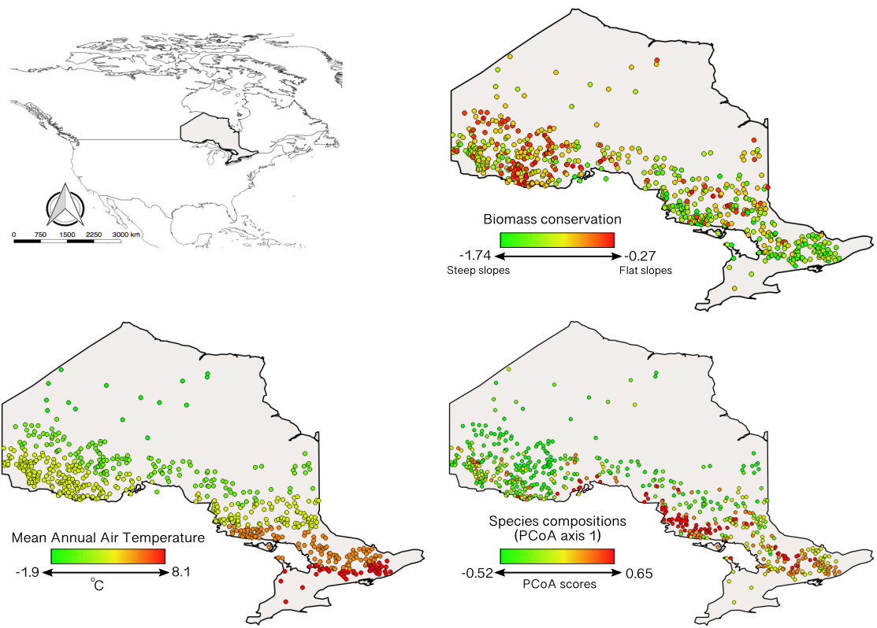

**Figure 1.** Distribution of lakes (coloured dots) in the Ontario region (top left) with corresponding information about biomass conservation (top right), mean air temperature (MAT, bottom left) and species compositions (bottom right). Species compositions are shown using axis 1 from the Principal Coordinates Analysis (PCoA) based on biomass data. Colour bars show the range of each variable.

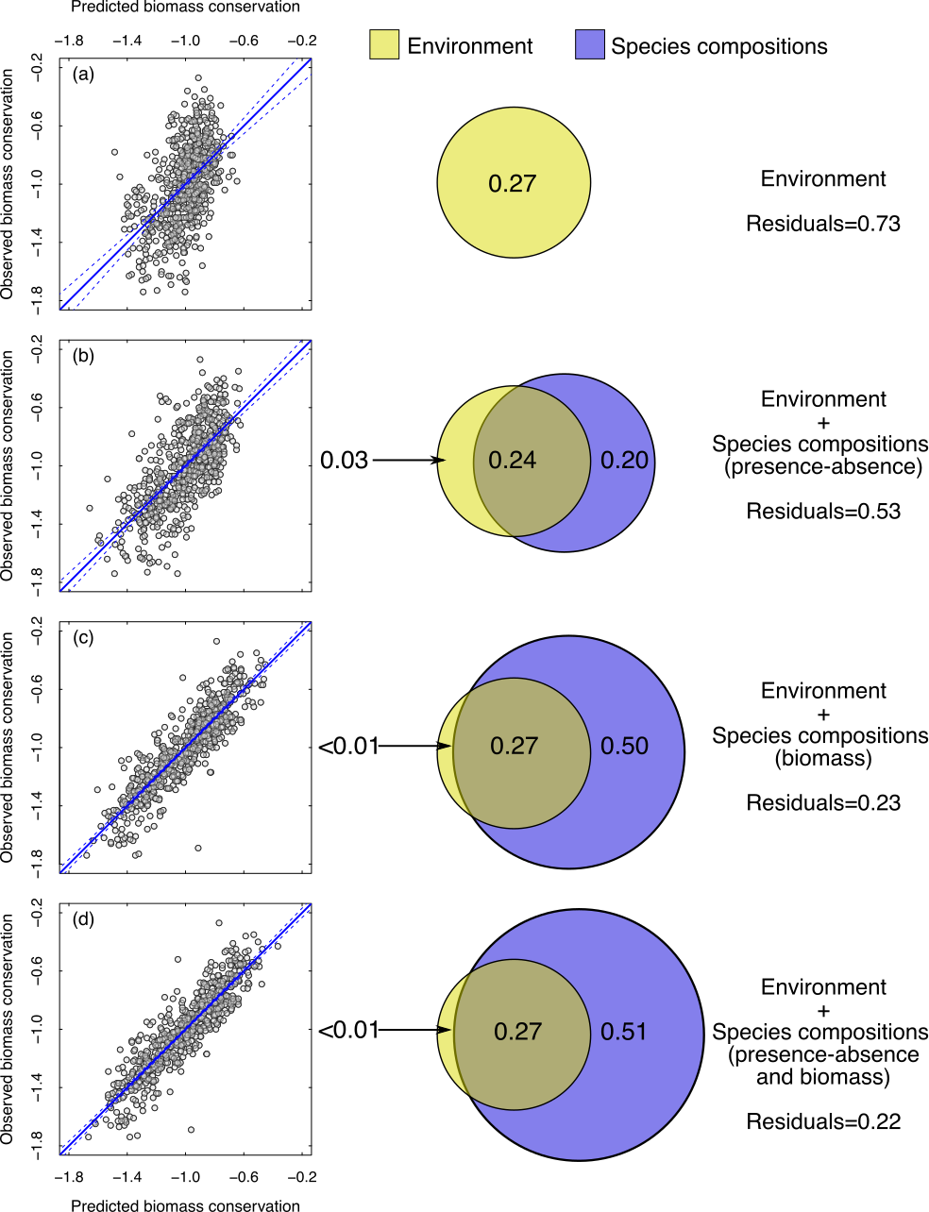

**Figure 2.** The effect of environmental variables and species compositions on biomass conservation. Scatterplots show the observed (*y*-axis) versus predicted (*x*-axis) values given models based on (a) the environment alone, (b) the environment plus species compositions measured by presence-absence data, and (c) the environment plus species compositions measured by species biomass, (d) the environment plus both measures of species compositions. Venn diagrams show the independent and shared contributions of the components, with numbers showing the proportion of variation explained (adjusted R2 values).

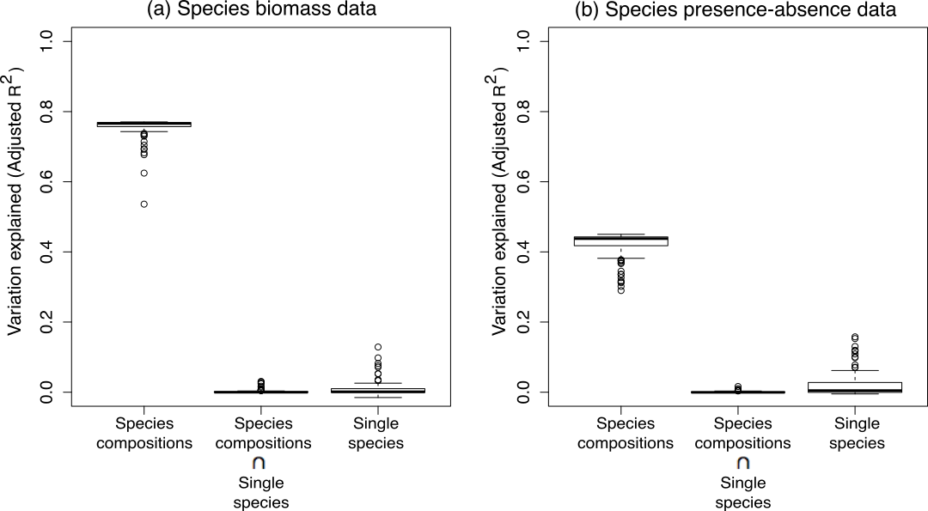

**Figure 3.** Boxplots contrasting the independent contribution of species compositions, individual species and their shared contribution based on adjusted semi-partial R2 for (a) biomass composition data and (b) presence-absence composition data. This was done using a jackknife procedure. Each species was dropped from the original matrices (biomass and presence-absence data) and the PCoA axes were recalculated without the target species. Then, the adjusted semi-partial R2 were computed using variation partitioning with the PCoA axes estimated and the original values of the target species. The procedure is repeated according to the total number of species in the data. Species compositions: effects of species compositions on biomass conservation regardless of target species; Single species: effects of single species on biomass conservation regardless of species compositions. Species compositions Single species: shared effects of species compositions and single species on biomass conservation.

~~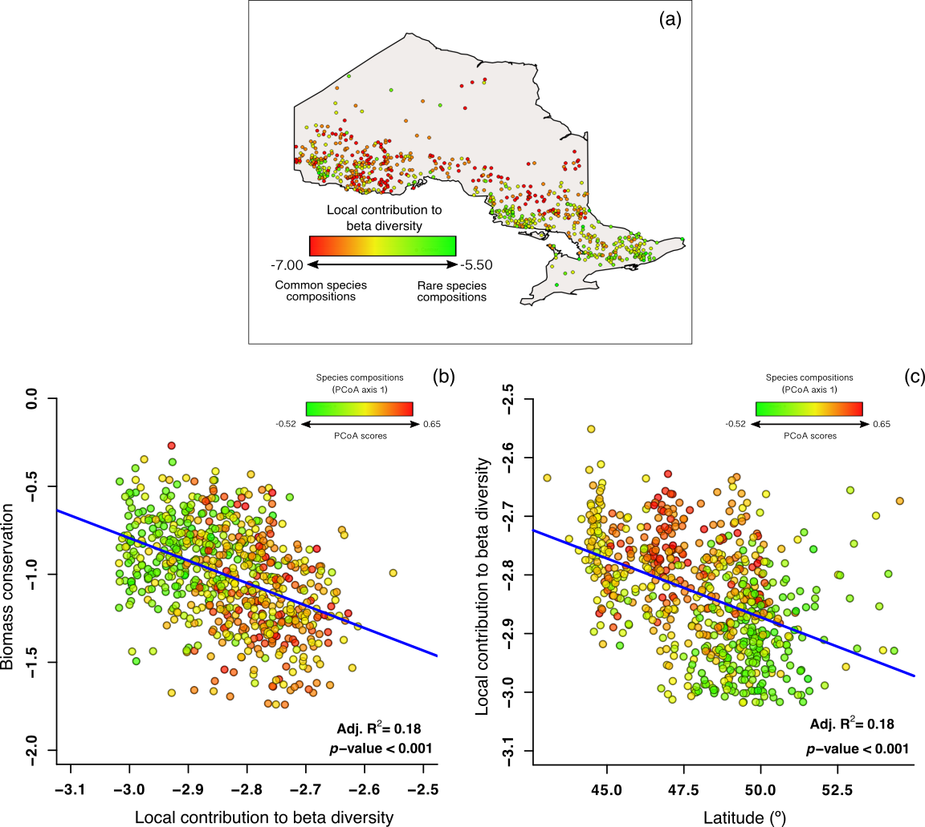~~

**Figure 4.** (a) Distribution of lakes (colored dots) in Ontario with corresponding information about the local contribution of beta diversity (LCBD). Colour gradients represent the degree of similarity among species compositions across lakes. Red dots indicate that the compositions of fish species were similar whereas green dots indicate communities with uncommon composition of fish species; (b) Relationship between biomass conservation (*y*-axis) and LCBD (*x*-axis); (c) The relationship between LCBD (*y*-axis) and latitude (*x*-axis). Panels (a) through (c) together show that biomass conservation is lower in southern communities where there is a higher frequency of uncommon species compositions. Colored dots in panels (b) and (c) correspond the first PCoA axis represented in Fig. 1.

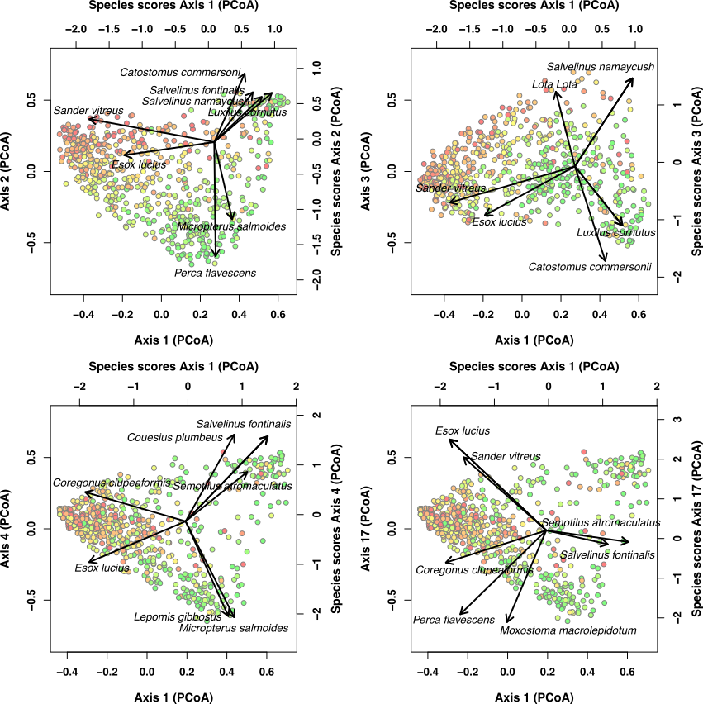

**Figure 5.** Principal coordinate analysis (PCoA) biplots of the most relevant species (i.e., species with high scores on the axes) on the most important PCoA axes predicting biomass conservation. Top biplots refer to biomass composition data whereas bottom biplots are presence-absence composition data. Dots represent lakes. Lakes were coloured to illustrate values of the NBS slopes: dots with red colour represent lakes with high community conservation (i.e., the NBS slopes are relatively flat). In contrast, specific-lake green dots are fish communities with low biomass conservation (i.e., the NBS slopes are relatively steep). Bottom and left axes show the position of each lake for each PCoA axis. The choice of lake axes (1, 2 and 3 for biomass composition data and 1, 4 and 17 for presence-absence composition data) was according to their relative contributions to predicting biomass conservation. Axes on the top and right on the panel show species scores for each PCoA axis.

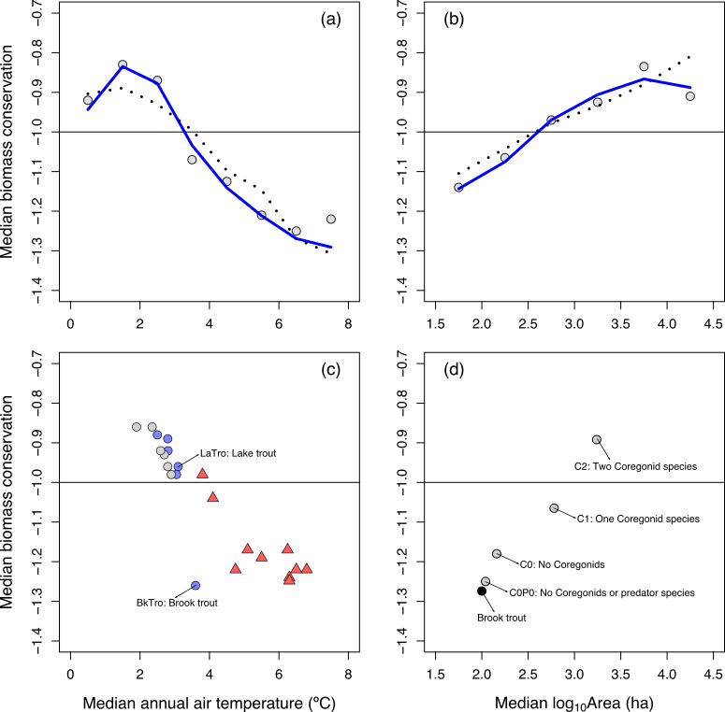

**Figure 6.** The effects of climate and lake size on biomass conservation. (a) Median biomass conservation (*y*-axis) is plotted against median annual air temperature in 1 °C intervals (*x*-axis); predicted medians based on the Environmental model (dashed line) and the Env+Species Compositions model (solid line) are also shown. (b) Median biomass conservation (*y*-axis) is plotted against median log10Area in 0.5 intervals (*x*-axis). (c) Median biomass conservation for various species (*y*-axis) is plotted against median annual air temperature of the lakes where each species was present (*x*-axis); the color of the shapes (circles and triangles) identify species belonging to different thermal guilds based on temperature preference: Cold (< 18°C, blue circle), Cool (18 – 24 °C, grey circle), Warm (> 24 °C, red triangle); labels identify lake trout (LaTro) and brook trout (BkTro). (d) Median biomass conservation is shown plotted against median lake size for lakes with brook trout (BkTro, black circle) and lake trout (grey circle). Lake trout lakes are labeled by community type: C0P0 – lacking Coregonids or predator species (i.e., Northern pike, walleye, smallmouth bass), C0 – lacking Coregonids, C1 – one Coregonid species is present, C2 – two Coregonid species (i.e., lake whitefish and cisco) are present.